# Honey offers a sweeter way to stop infections spreading

**Katie Gibbons**

September 27 2016, 12:01am, The Times

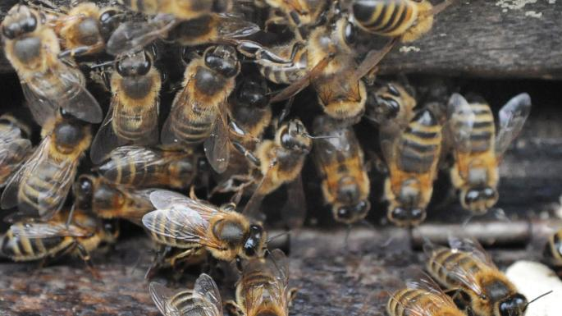

Honey produced from the nectar of the manuka tree has antiviral and antibacterial propertiesBARRY BATCHELOR/PA

Share

Save

It is normally spread on toast or stirred into tea to fight colds but manuka honey may soon find itself in hospitals as research shows that using it to coat medical implants could prevent infections.

Scientists at the University of Southampton found that the honey, which is known to heal cuts, boost immunity and improve skin conditions, could help keep internal devices such as urinary catheters disease-free.

The findings, published online in the *Journal of Clinical Pathology*, suggest that even low dilutions can curb the “stickiness” and growth of bacterial biofilms — a thin layer of microbes that builds up on any surface, including plastic. The manuka honey was diluted with distilled water and added to a neutral medium at different strengths. A dilution of 3.3 per cent was found to reduce stickiness 35 per cent after 48 hours, compared with artificial honey, which is made of sugar or corn syrup. A dilution of 16.7 per cent reduced stickiness by 77 per cent after three days.

Bashir Lwaleed, who led the study, said: “We have been able to demonstrate that diluted honey is potentially a useful agent for reducing biofilm formation. Catheter infection rates can account for a large proportion of hospital acquired infections — it is an area of clinical practice that needs addressing.”

Manuka honey is produced in Australia and New Zealand from the nectar of the manuka tree. Thick, dark brown and earthy-tasting, it has antiviral and antibacterial properties that can help to boost the immune system.

“We hope that these results may offer an alternative way of preventing infections,” Associate Professor Lwaleed said. “Patients might also benefit from honey’s anti-inflammatory properties, which are generally stronger in dark honeys.”